**Stored functions**

A stored function in MySQL is a set of SQL statements that perform some task/operation and return a single value. It is one of the types of stored programs in MySQL. When you will create a stored function, make sure that you have a CREATE ROUTINE database privilege. Generally, we used this function to encapsulate the common business rules or formulas reusable in stored programs or [SQL](https://www.javatpoint.com/sql-tutorial) statements.

The stored function is almost similar to the procedure in [MySQL](https://www.javatpoint.com/mysql-tutorial), but it has some differences that are as follows:

* The function parameter may contain only the **IN parameter** but can't allow specifying this parameter, while the procedure can allow **IN, OUT, INOUT parameters**.
* The stored function can return only a single value defined in the function header.
* The stored function may also be called within SQL statements.
* It may not produce a result set.

Types of Function

1. System Defined Function

These functions are defined by [**SQL Server**](https://www.dotnettricks.com/learn/sqlserver/introduction-to-sql-server) for a different purpose. We have two types of system defined function in SQL Server

* 1. Scalar Function

Scalar functions operate on a single value and return a single value. Below is the list of some useful **SQL Server Scalar functions.**

System Scalar Function

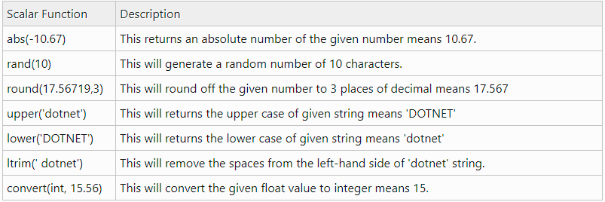

## Aggregate Function

Aggregate functions operate on a collection of values and return a single value. Below is the list of some useful SQL Server Aggregate functions.

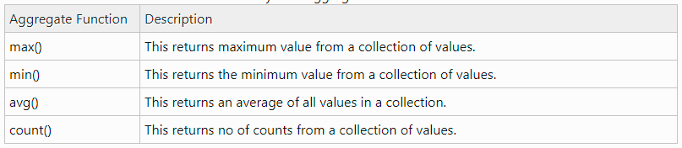

## User Defined Function

These functions are created by the user in the system database or in a user-defined database. We three types of user-defined functions.

## Scalar Function

The user-defined scalar function also returns a single value as a result of actions performed by the function. We return any datatype value from a function.

## 2.Inline Table-Valued Function

The user-defined inline table-valued function returns a table variable as a result of actions performed by the function. The value of the table variable should be derived from a single SELECT statement.

## 3.Multi-Statement Table-Valued Function

A user-defined multi-statement table-valued function returns a table variable as a result of actions performed by the function. In this, a table variable must be explicitly declared and defined whose value can be derived from multiple **SQL statements.**

Create table

CREATE TABLE developers (

ID INT,

NAME VARCHAR(255),

LEVEL VARCHAR(50),

AGE INT,

SALARY INT

);

INSERT INTO developers values ('1','anji','.SR','28','85590.567832');

INSERT INTO developers values ('2','priyanka','.SR','26','80000');

INSERT INTO developers values ('3','sonu','.JR','22','60000');

INSERT INTO developers values ('4','arya','.JR','24','50000');

INSERT INTO developers values ('5','narayana','.JR','24','70000');

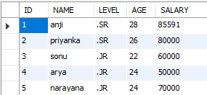

SELECT ABS(-123);



SELECT RAND(5);



SELECT ROUND (456.123);



SELECT UPPER('anji');



SELECT LOWER('ANJI');



SELECT LTRIM(' ANJI ');

SELECT RTRIM(' ANJI ');





SELECT

MAX(SALARY)

FROM

developers;



SELECT

MIN(SALARY)

FROM

developers;



SELECT

AVG(AGE)

FROM

developers;



SELECT

COUNT(ID)

FROM

developers;

